Keyboard shortcuts

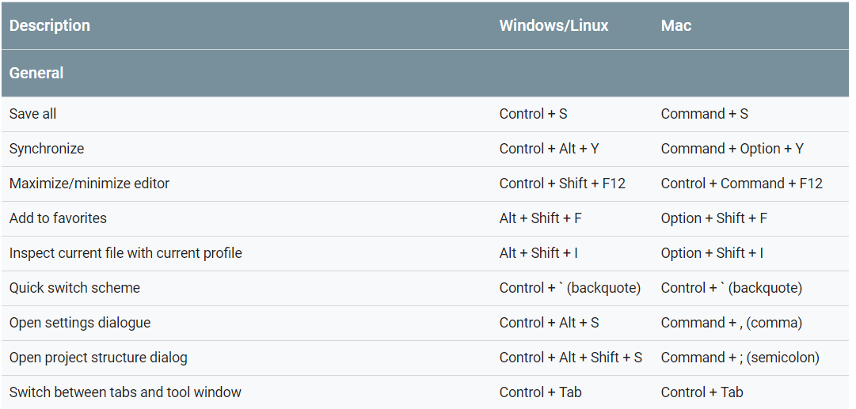

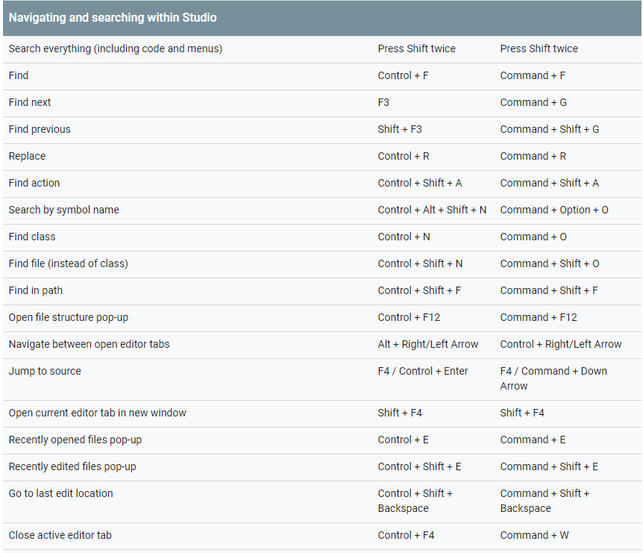

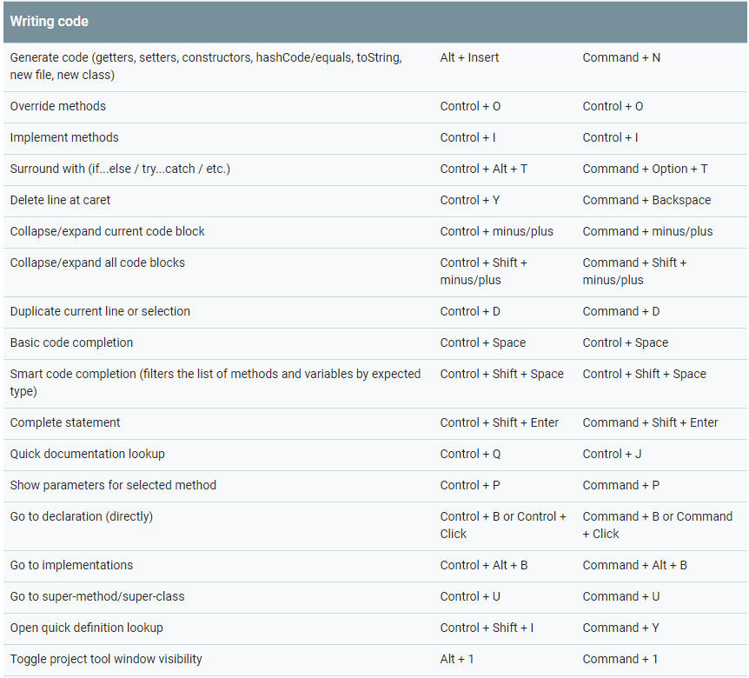

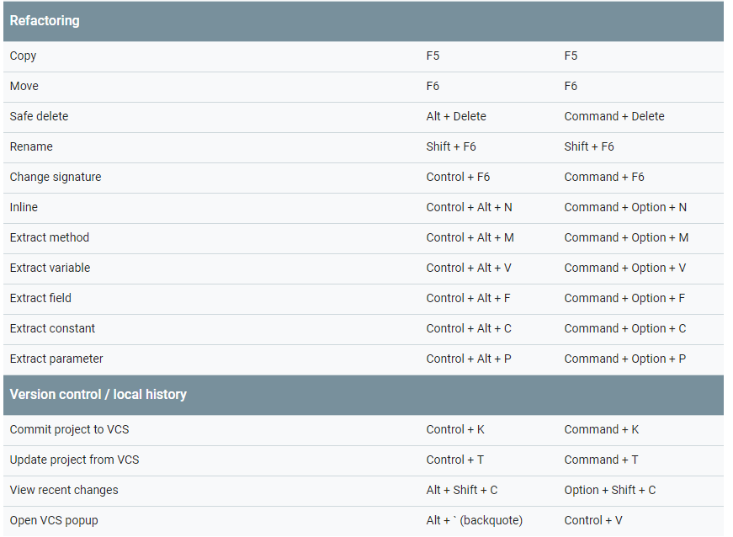

## Configure custom keymaps

You can choose from a number of preset keymaps or modify a preset keymap to create a new custom keymap in the keymap settings for Android Studio.

To open the keymap settings, choose **File > Settings** (on Mac, **Android Studio > Preferences**) and navigate to the **Keymap** pane.

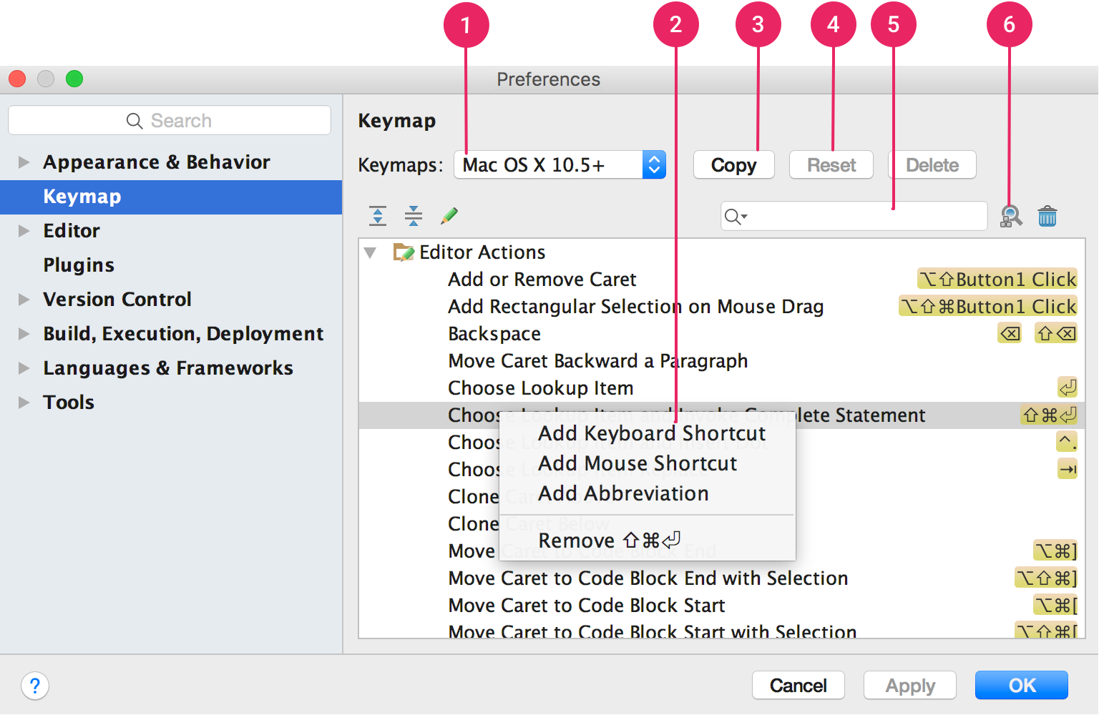

**Figure 1.** The Android Studio keymap settings window.

1. **Keymaps dropdown:** Select the desired keymap from this menu to switch between preset keymaps.
2. **Actions list:** Right click on an action to modify it. You can add additional keyboard shortcuts for the action, add mouse shortcuts to associate an action with a mouse click, or remove current shortcuts. If you are using a preset keymap, modifying an action’s shortcuts will automatically create a copy of the keymap and add your modifications to the copy.
3. **Copy button:** Select a keymap from the dropdown menu to use as a starting point, and click **Copy** to create a new custom keymap. You can modify the keymap name and shortcuts.
4. **Reset button:** Select a keymap from the dropdown menu and click **Reset** to revert it to its original configuration.
5. **Search box:** Type here to search for a keyboard shortcut by the action name.
6. **Search by Shortcut:** Click **Find Actions by Shortcut** and type a shortcut to search for actions by shortcut.